2CS 419 Compiler
Project Form

Project Idea: Project #1
Description:
A program in Project #1 consists of a sequence of function definitions -.
Each function consists in turn of variable declarations, type declarations,
function declarations, and statements. The types in Project #1 are very
restricted look at table 1.in addition to table 1, single dimensional arrays and
pointer types are possibly using user defined struct types as in C Language.
The array index value can only be simple unary expression such as an
identifier, a constant or another simple array access expression. Project# 1
Language is case sensitive
……………………………………………………………….
Team Members NO#: 7
ID | Name | Level&  Department | Section(Day-from-to) | Role  (Lead/Member) | Grade
201900836 | معاذ احمد نجيب | Level3 &CS | Wednesday  2-4 | leader
201900577 | كريم احمد متولي محمد | Level3 &CS | Wednesday  4-6 | Member
201900566 | فاطمة محمود فؤاد محمود | Level3 &CS | Wednesday  4-6 | Member
201900772 | محمود طه احمد علي | Level3 &CS | Wednesday  4-6 | Member
201900935 | هدير سامح داود محمد | Level3 &CS | Wednesday  2-4 | Member
201900919 | نيفين حمدي سعد احمد | Level3 &CS |  | Member
201900162 | الاء محمدى عبدالعظيم السيد | Level3 &CS |  | Member
Regular Expression, Finite automata and Conversion from RegX to
NFA, NFA to DFA

Regular Expression :
Letter | ( [A-Z] | [a-z] )
Digit | [ 0-9 ]
Digits | Digit +
Sign | + | -
Condition | If—Else
Integer | Iow
SInteger | SIow
Character | Chlo
String | Chain
Float | Iowf
SFloat | SIowf
Void | Worthless
Loop | (Loop | Iterate) when
Return | Turnback
Break | Stop
Struct | Loli
Arithmetic  Operation | (+| -| *| /)
Logic  Operators | (&& | || | ~)
relational  operators | (== | < | > | != | <= | >=)
Assignment  operator | =
Access  Operator | ->
Braces | ({ | } | [ | ])
Constant | Digits
Quotation  Mark | ,
Inclusion | Include
NFA:
- Identifier :- Letter (letter | digit )
letter
ϵ
5
4
ϵ
ϵ
ϵ
ϵ
letter
Identifier
ϵ
9
8
3
2
1
0

digit
ϵ
7
6

- )If | Else) :- Condition
I
f
3
22
4
ϵ
ϵ

ϵ
ϵ
Condition
10
11
ϵ
ϵ
1
0

8
9
7
e
s
l
E
6
5

- Integer :- Iow
w
o
I
Integer
3
2
1
0

- SInteger : SIow

I
w
o
S
SInteger
4
3
2
1
0

- Character : - Chlo
I
o
h
c
Character
4
3
2
1
0

- String :- Chain
n
i
a
h
c
String
5
4
3
2
1
0

- Float :- Iowf
f
I
o
w
Float
4
3
2
1
0

- Sfloat :- SIowf
s
f
w
o
I
Sfloat
5
4
3
2
1
0

- Void :- worthless

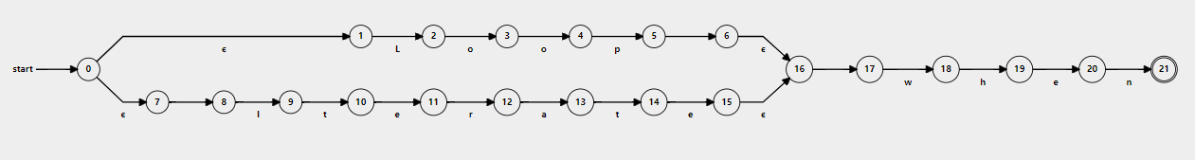
10- Loop :- (Loop | Iterate) when

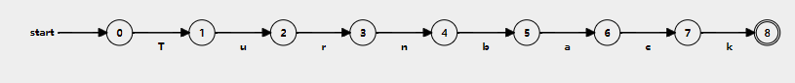
11- Return :- Turnback

12- Break :- Stop
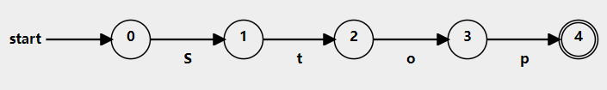
13- Struct :- Loli
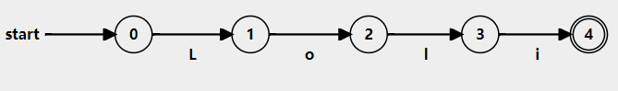
14- Arithmetic Operation :- (+| -| *| /)
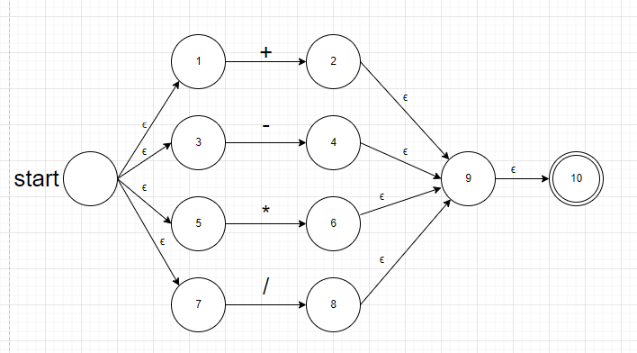
15- Logic Operators :- (&& | || | ~)
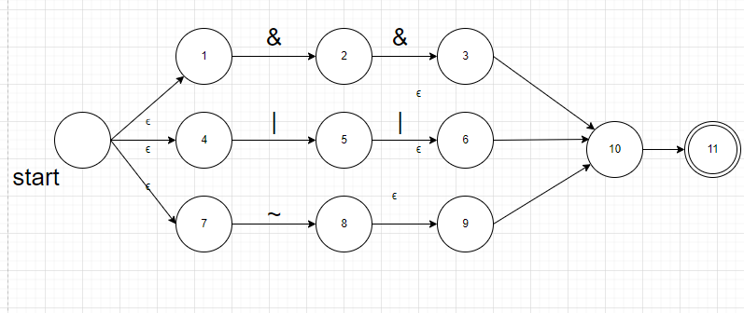
16- relational operators :- (== | < | > | != | <= | >=)
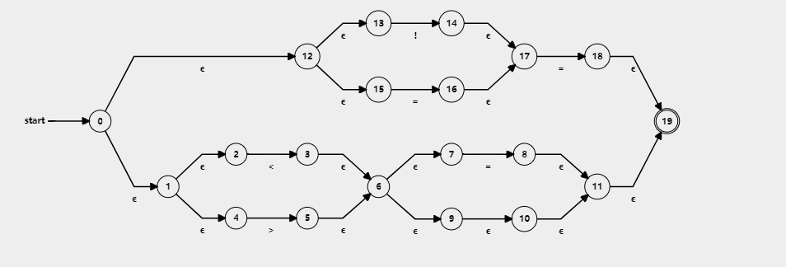
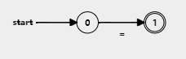
17- Assignment operator :- =

18- Access Operator :- ->
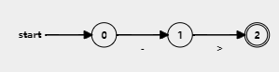

19- Braces :- ({ | } | [ | ])
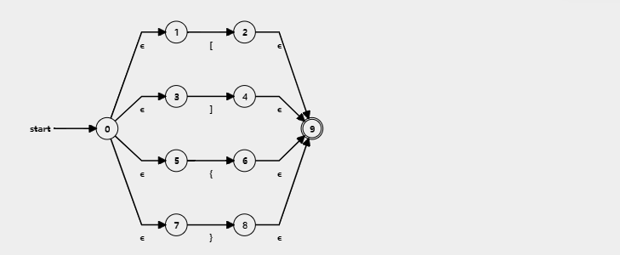

20-Constant :- Digit+
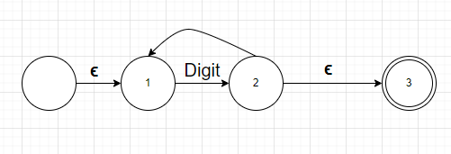
21- Quotation Mark :- ,
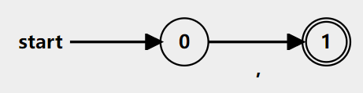
22- Inclusion :- Include
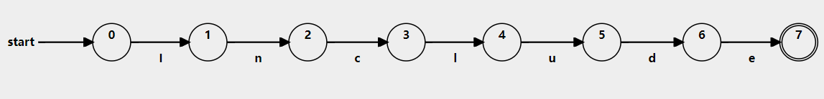

DFA:-
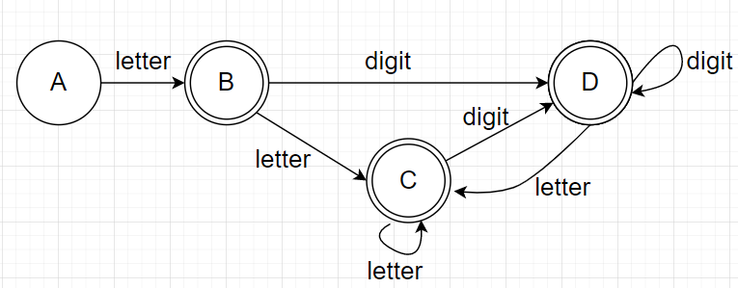
- Identifier :- Letter (letter | digit )

Minimum DFA
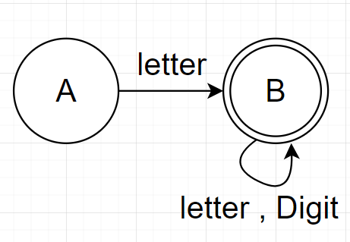
- (If | Else) :- Condition
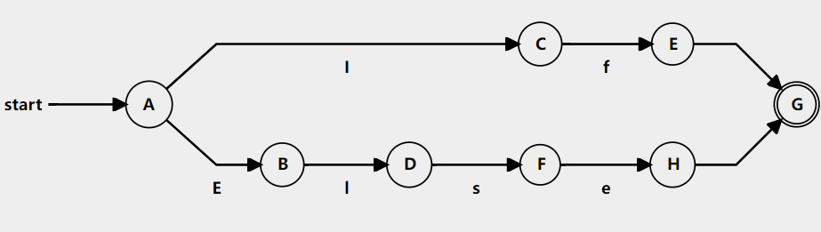
3-Integer :- Iow
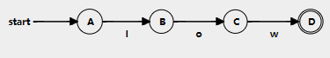

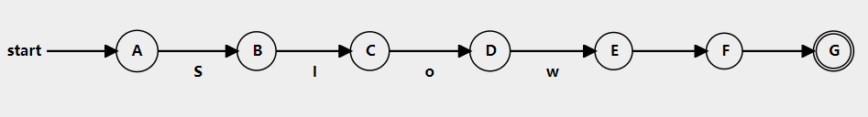
4- SInteger : SIow

- Character : - Chlo
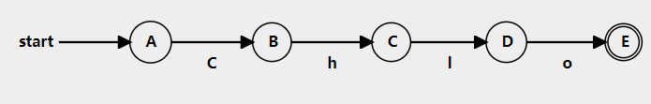
- String :- Chain
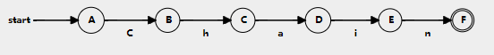
- Float :-
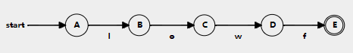

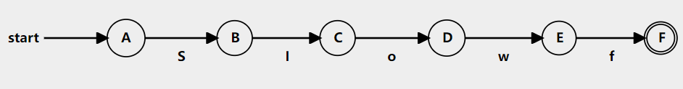
- Sfloat :- SIowf

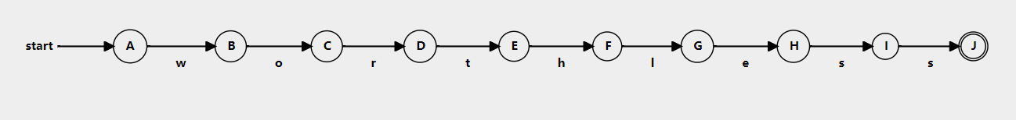
- Void :- worthless
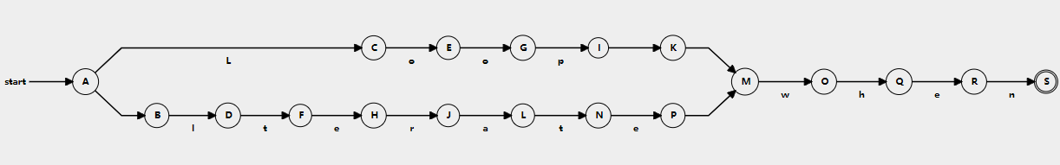
10- Loop :- (Loop | Iterate) when

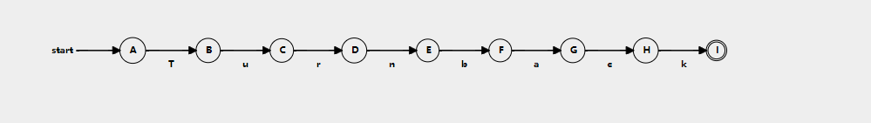
11- Return :- Turnback

12- Break :- Stop
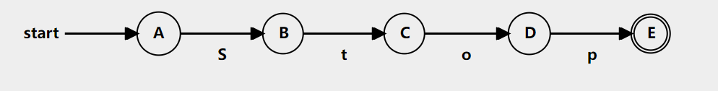
13- Struct :- Loli
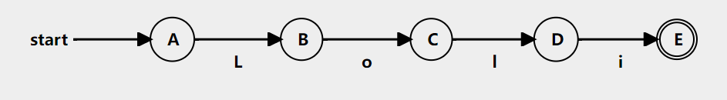
14- Arithmetic Operation :- (+| -| *| /)
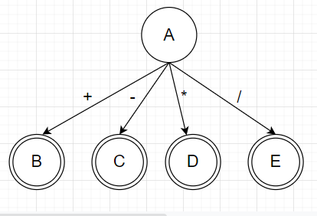

15- Logic Operators :- (&& | || | ~)
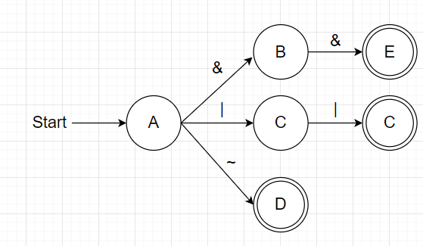
16- relational operators :- (== | < | > | != | <= | >=)
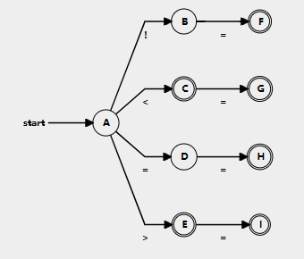
17- Assignment operator :- =
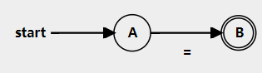

18- Access Operator :- ->
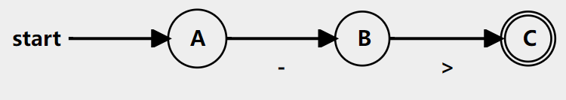
19- Braces :- ({ | } | [ | ])
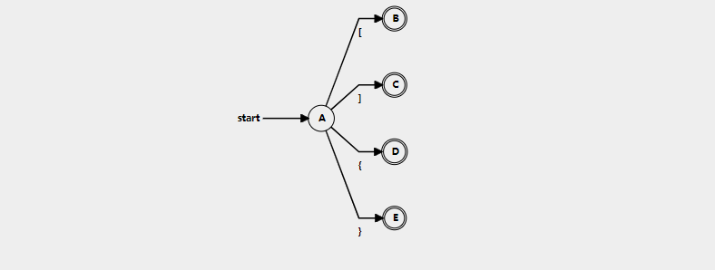
20-Constant :- Digit+
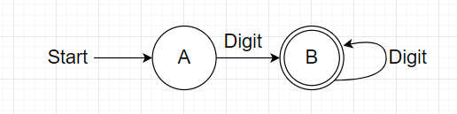
21- Quotation Mark :- ,
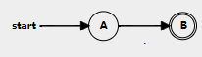
22- Inclusion :- Include
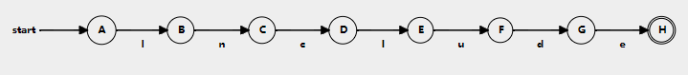
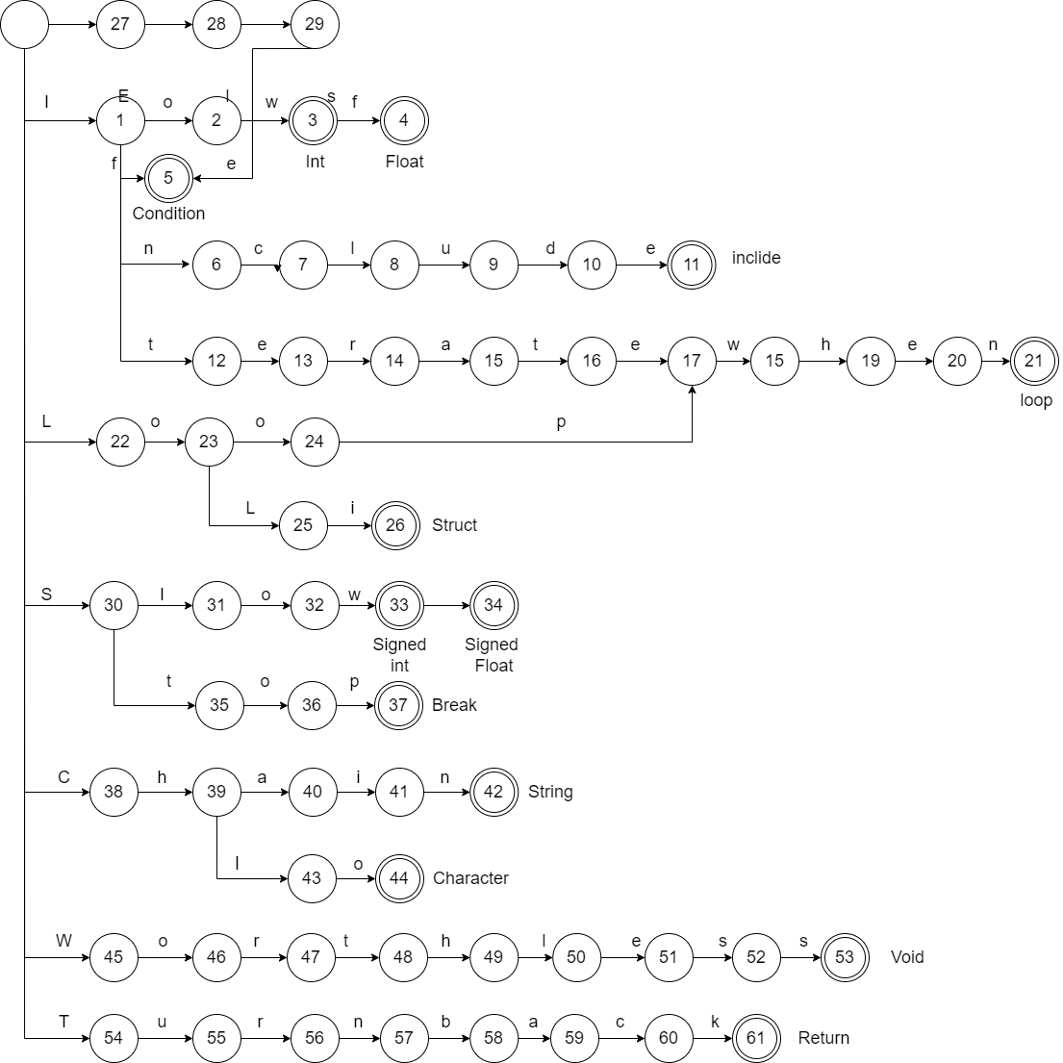
Keywords :-

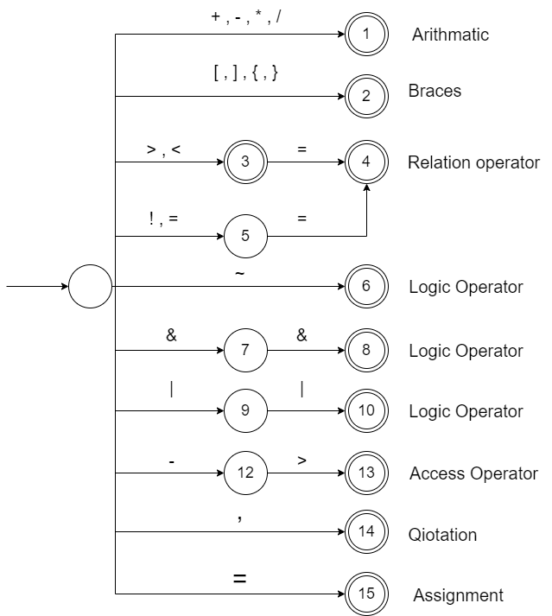

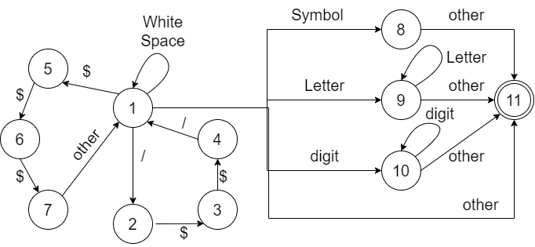
 | White | / | $ | other | Letter | digit | Symbol | Accept
1 | 1 | 2 | 5 | 11 | 9 | 10 | 8 | No
2 |  |  | 3 |  |  |  |  | No
3 |  |  | 4 |  |  |  |  | No
4 |  | 1 |  |  |  |  |  | No
5 |  |  | 6 |  |  |  |  | No
6 |  |  | 7 |  |  |  |  | No
7 |  |  |  | 1 |  |  |  | No
8 |  |  |  | 11 |  |  |  | No
9 |  |  |  | 11 | 9 |  |  | No
10 |  |  |  | 11 |  | 10 |  | No
11 |  |  |  |  |  |  |  | Yes

Left Recursion :
- program → declaration-list | comment | include_command

2. declaration-list → declaration-list declaration | declaration
declaration-list → declaration declaration-list’
declaration-list’ → declaration declaration-list’ | ϵ
- declaration → var-declaration | fun-declaration
4. var-declaration → type-specifier ID ;
5. type-specifier → Iow | SIow | Chlo | Chain | Iowf | SIowf | Worthless
6. fun-declaration → type-specifier ID ( params ) compound-stmt|
comment type-specifier ID
7. params → param-list | Worthless | ϵ
8. param-list → param-list , param | param
param-list → param param-list’
param-list’ → , param param-list’ | ϵ
9. param → type-specifier ID
10. compound-stmt → {comment local-declarations statement-list } |
{local-declarations statement-list }
compound-stmt → { compound-stmt’
compound-stmt’ → comment local-declarations statement-list } |
local-declarations statement-list }

11. local-declarations →local-declarations var-declaration | ϵ
12. statement-list → statement-list statement | ϵ
13. statement → expression-stmt | compound-stmt | selection-stmt |
iteration-stmt | jump-stmt
14. expression-stmt → expression ; | ;
15. selection-stmt → if ( expression ) statement
| if ( expression ) statement else statement
selection-stmt → if ( expression ) statement selection-stmt’
selection-stmt’ → else statement | ϵ
16. iteration-stmt → Loop-statement | Iterate-statement
17. Loop-statement → Loopwhen( expression ) statement

18. Iterate -statement → Iteratewhen ( expression ; expression ; expression
) statement
19. jump-stmt → Turnback expression ; | Stop ;
20. expression → id-assign = expression | simple-expression | id-assign
expression → id-assign expression’ | simple-expression
expression’ → = expression | ϵ
21. id-assign → ID
22. simple-expression
→ additive-expression relop additive-expression | additive-expression
simple-expression → additive-expression simple-expression’
simple-expression’ → relop additive-expression | ϵ
23. relop → <= | < | > | >= | == | != | && | ||
24. additive-expression → additive-expression addop term | term

additive-expression → term additive-expression’
additive-expression’ → addop term additive-expression’ | ϵ
25. addop → + | -
26. term → term mulop factor | factor
term → factor term’
term’ → mulop factor term’ | ϵ
27. mulop → * | /
28. factor → ( expression ) | id-assign | call | num
29. call → ID ( args )
30. args → arg-list | e
31. arg-list → arg-list , expression | expression
arg-list → expression arg-list’
arg-list’ → , expression arg-list’ | ϵ
32. num → Signed num |Unsigned num
33. Unsigned num → value
34. Signed num → pos-num | neg-num
35. pos-num → + value
36. neg-num → - value
37. value → INT_NUM | FLOAT_NUM
38. comment →/* STR */ | /// STR
39. include_command →include (F_name.txt);
40. F_name →STR

